Module Settings

- Description
This module manages basic application settings.

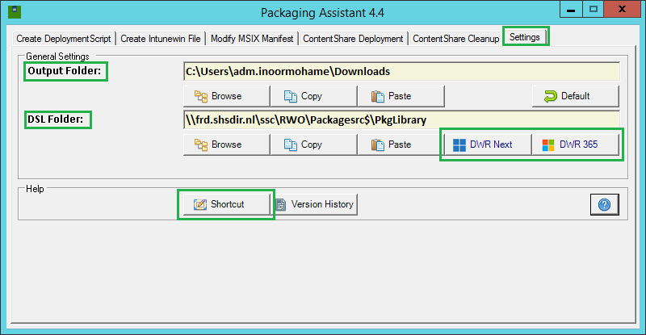

- Instructions

- Output Folder:
Select a folder that will be used for most output files.

- DSL Folder:
Select your Package Library/ DSL folder. You can use the buttons DWR Next and DWR 365 to quickly switch between the two.

- Shortcut
This wil create a Desktop Shortcut.

